IMac installation Guide
- Turn off your iMac and disconnect all cables and power cord from your computer.
- Put a soft, clean towel or cloth on the desk or other flat surface to prevent scratching the LCD display and hold the sides of the computer and slowly put the computer screen face down on to the soft, clean towel or cloth surface.
- Remove the memory access door at the bottom of your computer with Philip screwdriver.

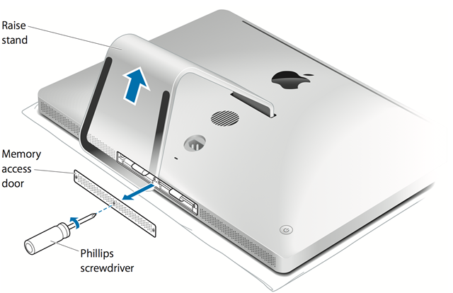
- Untuck the tabs in the memory compartment. If you are replacing a memory module, gently pull the tab outward to eject any installed memory module.
- Please note: it is important that you discharge any static electricity which may have built up in your body or clothing before handling the memory modules to avoid damage. This can be done by:
  - Touching an unpainted, grounded metal surface first.
  - Alternatively, you can wear an Electro Static Discharge (ESD) protective wrist strap.
  - Holding the memory module at the edges and avoiding contact with the memory chips.

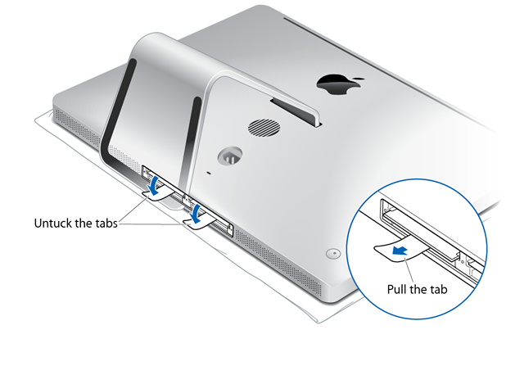

- Insert and push your new or replacement SO-DIMM into the empty slot. There should be a click when you put the memory in correctly.
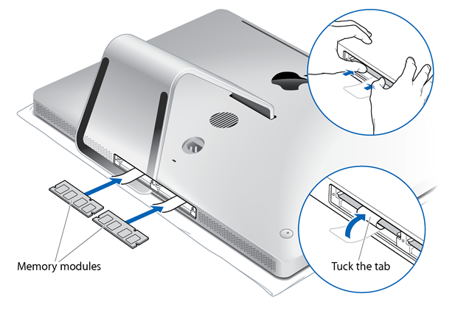
- Tuck the tabs above the memory SO-DIMMs, and reinstall the memory access door.
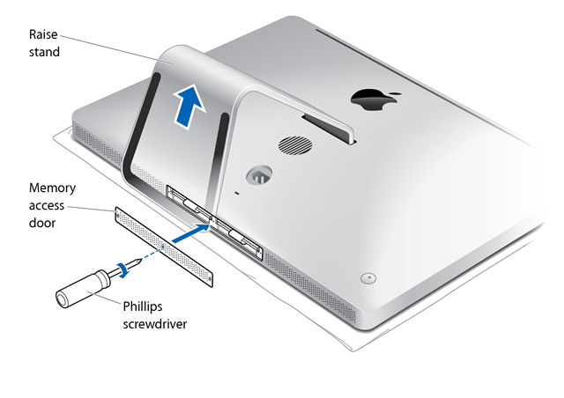
- Stand the computer in its upright position, reconnect the power cord and all other cables to the computer, then start up the computer.
- Most computers will automatically recognize the upgraded memory on the next boot, while some may require you to configure the new memory. In this instance, please check your computer and operating system user guides.
- The installation of memory modules is complete.
- For more support details, warranty and return policy, do visit the other sections on www.strontium.biz

